- The rover operates on a 2-motor system, with tank tracks spreading force across each side of the rover. The radius of the controlling wheels is 5 inches
- In the simulated area, 1 pixel = 1 inch, and in total, the simulated area is 800 by 600 inches

Motion Plan

- Drive both motors forward until the rover detects it is within a certain distance of the obstacle (contact)
- Drive both motors backwards for 1 second
- Drive the Left actuator forward and the right actuator backward to turn in place clockwise, continuing until the rover is facing downward (270* + 5* margin)
- Drive both actuators forward to move downward, continuing forward until the rover's y level matches the y level of the goal
- Drive the right actuator forward and the left actuator backward to turn in place counterclockwise, continuing until it is facing right (0* + 5* margin)
- Drive both actuators forward, moving until it reach the goal and the simulation ends

Formulas Used

Wheel travel
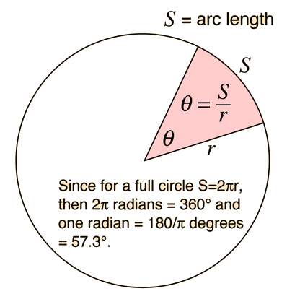
Differential Drive Kinematics (Turning)

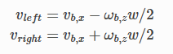
Converting Vector Movement to 2-dimensional translation
